Welcome to the Allegheny County Department of Human Services (ACDHS) QuickCount Tool!
QuickCount allows for queries about participation in a wide range of services from data integrated in the DHS Data Warehouse. Users can sort by time period, view participation in multiple services, and filter counts demographically and geographically.

Getting a QuickCount of program participation is easy. No login is needed to use this tool.

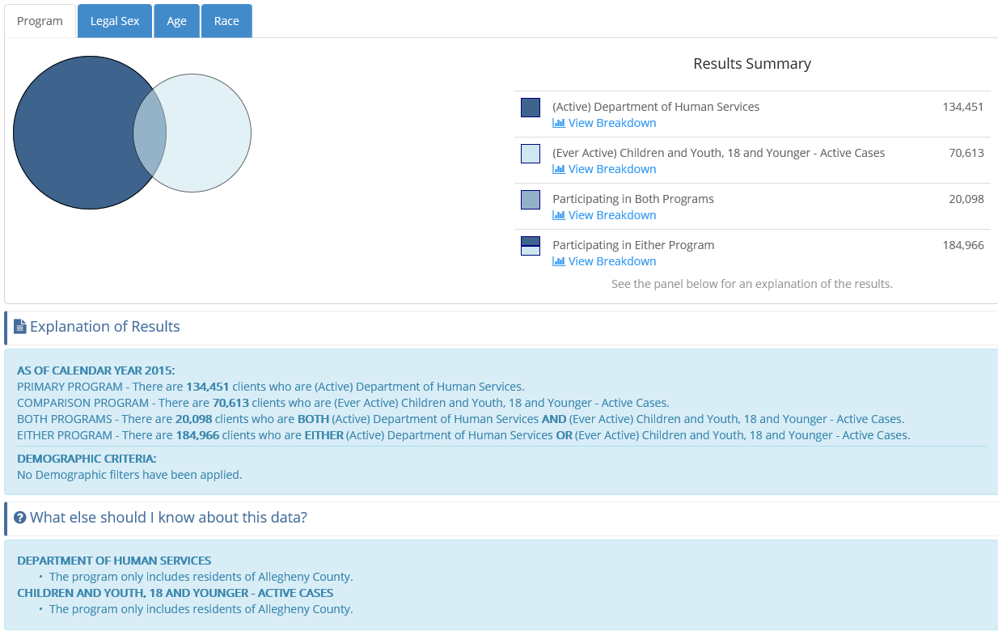
Make your selections, only Time Period and Primary Program are required.

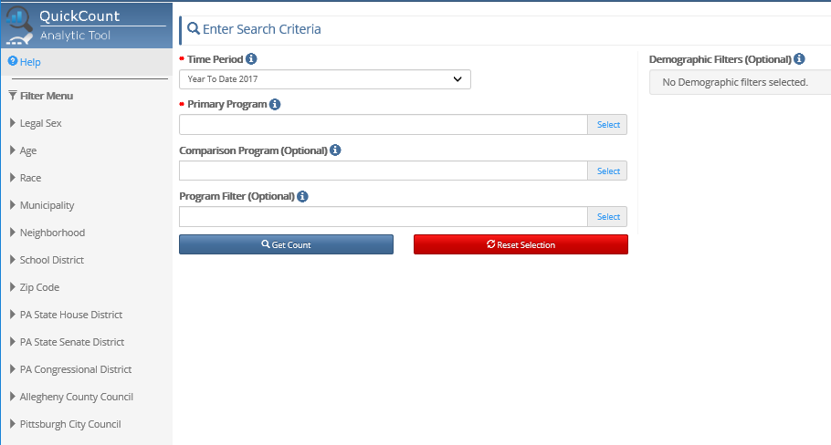

Add more data to the results by also selecting a Comparison Program.

Filter the results, by selecting a Program Filter, demographic filter or geographical filter from the Filter Menu.

Help is available within the application by:

Clicking Help located in the upper left
Clicking the Information Icon next to each selection
Clicking Download Program List which can be found under each Program Selection and contains descriptions as well as other information.

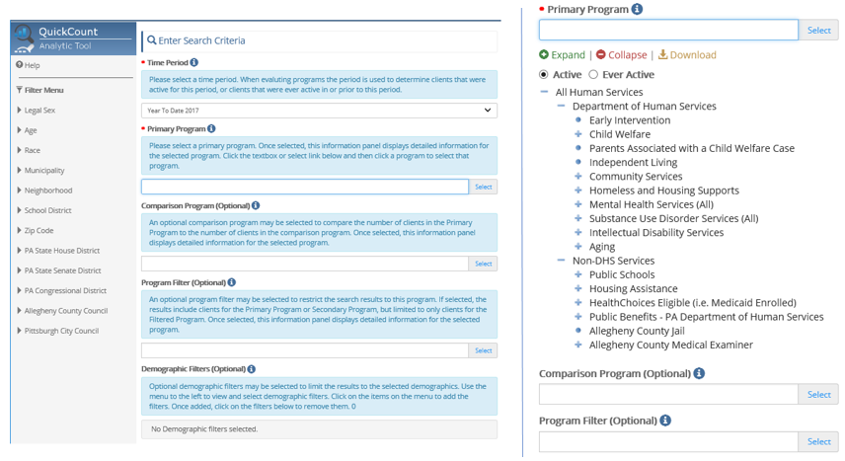

Let’s walk through some examples.
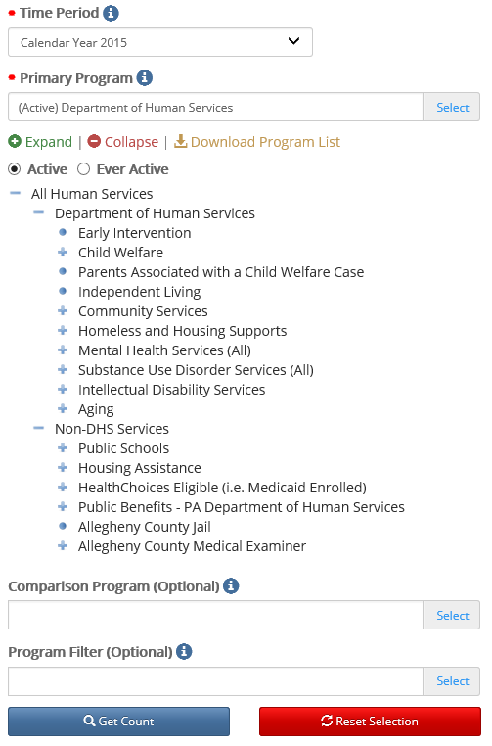
Question 1:
How many clients were active with DHS in 2015?

Steps:
Click Time Period and choose Calendar Year 2015 from the list.

Click Primary Program, choose Active, and select Department of Human Services.

Click Get Count

*Note: Currently Active refers to the time period chosen. So, in this example, Currently Active = active in 2015.

Hints:
Active and Ever Active seen at the top of the program list may be toggled simply by clicking the hollow dot to the left of the text.

The program tree may be expanded and collapsed wherever there is a + or – symbol. The dots represent the lowest level.

The QuickCount can be found at the bottom
of the screen, along with some additional information.

The results will be displayed in the lower part of the screen below the selection area. The narrative at the very bottom describes the selections and results. The tabs provide additional views of the data.

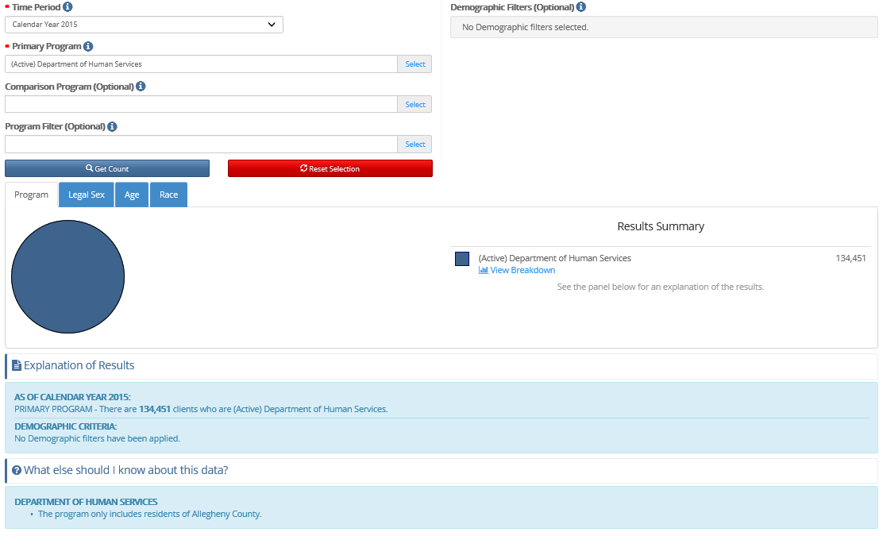
Question 2:
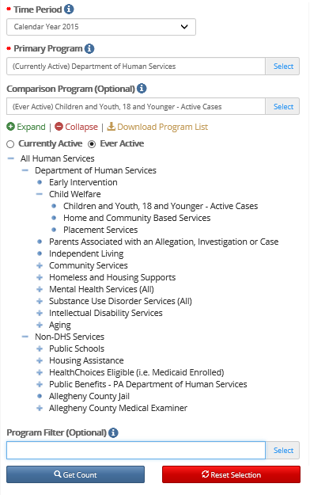
How many clients were active with DHS in 2015 and were ever part of an active case as children with Children and Youth Services?

Steps:
Click Time Period and choose Calendar Year 2015 from the list.

Click Primary Program, choose Active, and select Department of Human Services.

Click Comparison Program, choose Ever Active, and select Children and Youth, 18 or Younger – Active Cases.

Click Get Count

*Notes:
Active refers to the time period chosen. So, in this example, currently active = active in 2015.

Ever Active = Ever Active from the chosen date backwards in time. So, in this example, ever active = active before and through 2015.

Data has been added to the result as can be seen in the Results Summary, but the original count is still available.

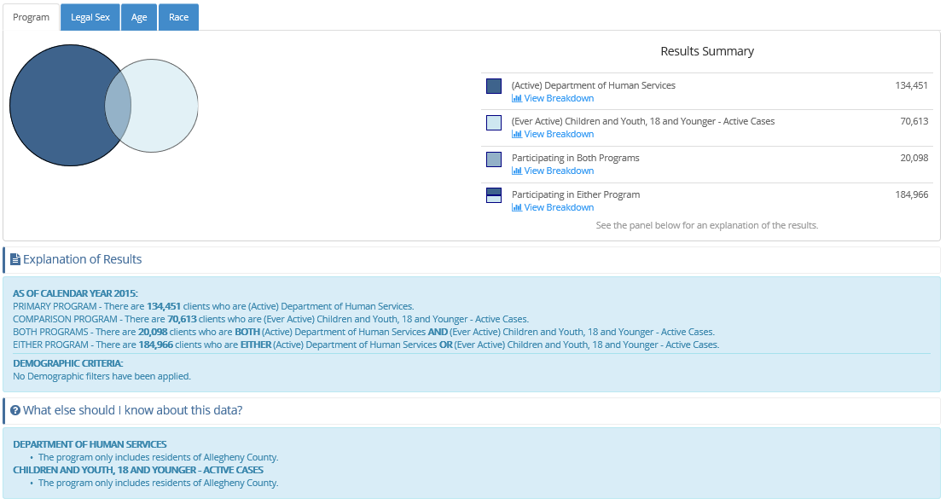
Clicking View Breakdown in the Results Summary will provide filtered details on the Legal Sex, Age and Race tabs. Clicking the tabs will provide details for both programs on the Legal Sex, Age and Race tabs

For example, to see breakdowns for clients in either program, simply click through the tabs or chose View Breakdown in the Results Summary under Participating in Either Program.
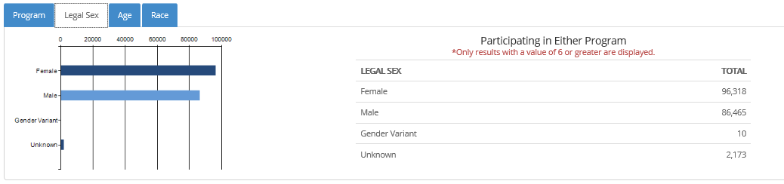

To choose another breakdown, choose the Program tab and change the selection.

To see breakdowns for clients in both programs, chose View Breakdown in the Results Summary under Participating in Both Programs.
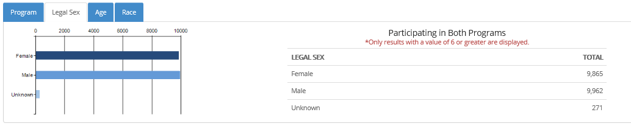
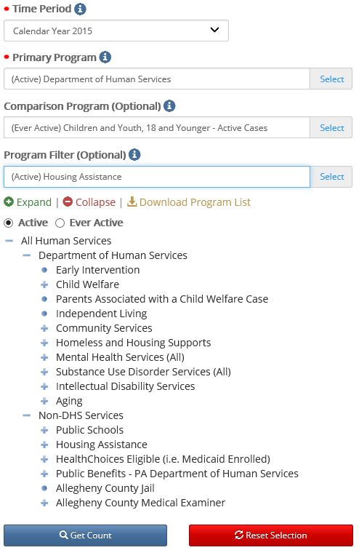
Question 3:
How many clients were active with DHS in 2015 and were ever part of an active case as children with Children and Youth Services and received non-DHS Housing Assistance?

Steps:
Click Time Period and choose Calendar Year 2015 from the list.

Click Primary Program, choose Active, and select Department of Human Services.

Click Comparison Program, choose Ever Active, and select Children and Youth, 18 or Younger – Active Cases.

Click Program Filter, choose Active, and select Housing Assistance under non-DHS Services.

Click Get Count

*Notes:
Active refers to the time period chosen. So, in this example, currently active = active in 2015.

Ever Active = Ever Active from the chosen date backwards in time. So, in this example, ever active = active before and through 2015.

Notice the results are now FILTERED to those clients matching the filter criteria. The narrative explains further.

Data has been removed from the result, or filtered by the program filter, which can be seen in the Results Summary. The results are limited to meet the filter requirements, in this case, counts are limited to clients receiving Housing Assistance.

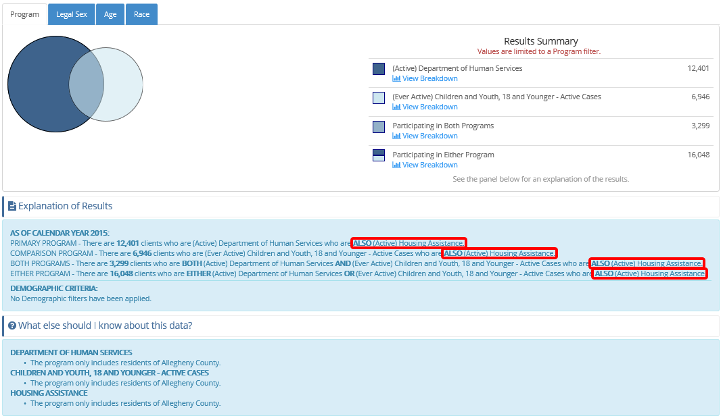

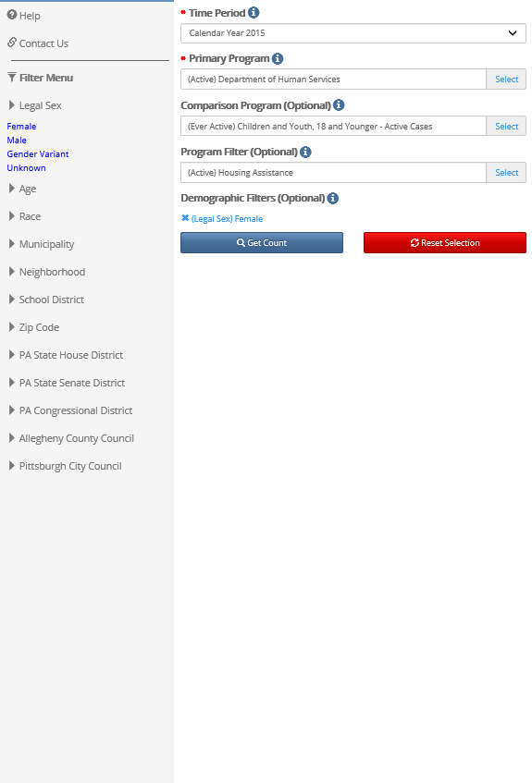
Question 4:
How many clients were active with DHS in 2015 and were ever part of an active case as children with Children and Youth Services and received non-DHS Housing Assistance and were female?

Steps:
Click Time Period and choose Calendar Year 2015 from the list.

Click Primary Program, choose Active, and select Department of Human Services.

Click Comparison Program, choose Ever Active, and select Children and Youth, 18 or Younger – Active Cases.

Click Program Filter, choose Active, and select Housing Assistance under non-DHS Services.

In the Filter Menu to the left, expand Legal Sex and select Female.

Click Get Count

*Hint – selections can be seen in the demographic filter section. Notice the results are now FILTERED to those clients matching the filter criteria. The narrative explains further.

*Notes: Active refers to the time period chosen. So, in this example, currently active = active in 2015.

Ever Active = Ever Active from the chosen date backwards in time. So, in this example, ever active = active before and through 2015.

More data has been removed from the result, or filtered by the demographic filter, which can be seen in the Results Summary. The results are limited to meet the filter requirements, in this case, counts are limited to clients who are were female.

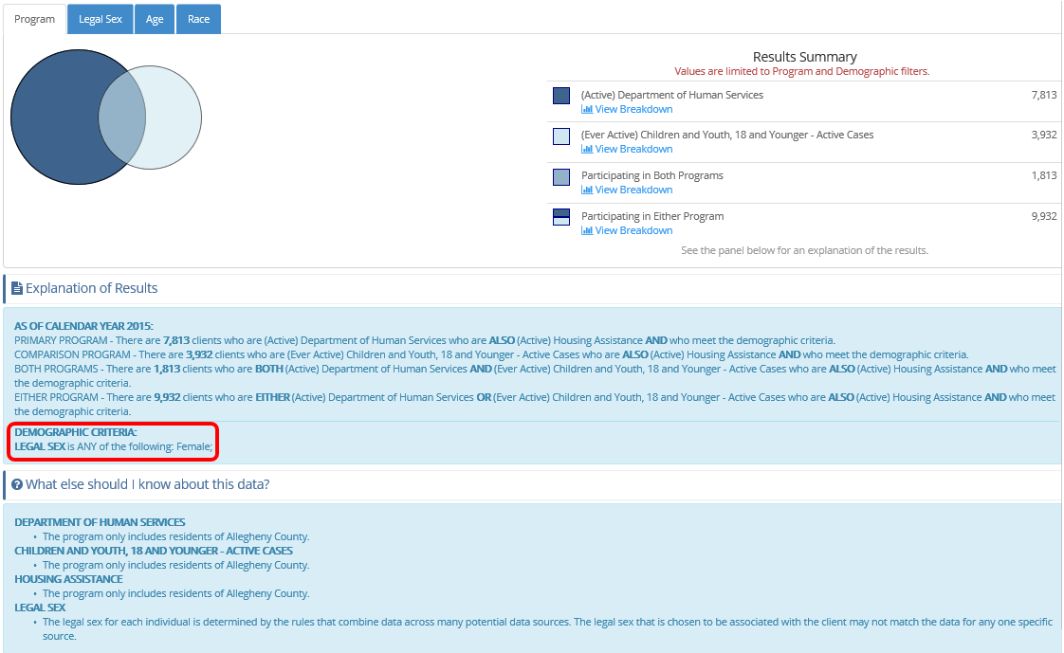
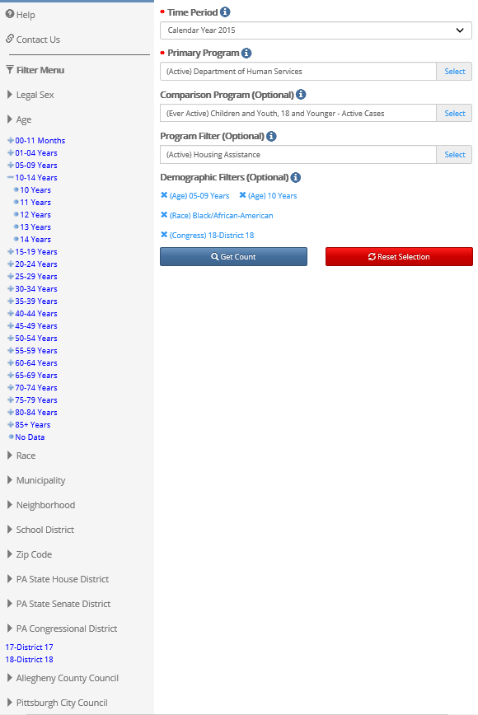
Question 5:
How many clients were active with DHS in 2015 and were ever part of an active case as children with Children and Youth Services and received non-DHS Housing Assistance and were female African American, between the ages of 5 - 10 and resided Pennsylvania’s 18th congressional district?

Steps:
Click Time Period and choose Calendar Year 2015 from the list.

Click Primary Program, choose Active, and select Department of Human Services.

Click Comparison Program, choose Ever Active, and select Children and Youth, 18 or Younger – Active Cases.

Click Program Filter, choose Active, and select Housing Assistance under non-DHS Services.

Under Demographic Filters, remove Female by clicking the X icon

In the Filter Menu to the left, expand Race and select African American,
expand Age and select 5-9 years, further expand Age 10-14 years and choose 10 years, expand PA Congressional District and select 18-District 18.

Click Get Count

*Hint – selections can be seen in the demographic filter section. Notice the results are now FILTERED to those clients matching ALL the filter criteria. The narrative explains further.

Result counts have changed again, which can be seen in the Results Summary. The results are limited to meet the ALL filter requirements, in this case, counts are limited to clients who are were African American, between the ages of 5-10 and lived in the 18th congressional district. The result is no longer being filtered to females because that filter criteria was removed.

