Welcome to the Allegheny County Department of Human Services (ACDHS) QuickCount Tool!

QuickCount allows for queries about participation in a wide range of services from data integrated in the DHS Data Warehouse. Users can sort by time period, view participation in multiple services, and filter counts demographically and geographically.

Getting a QuickCount of program participation is easy.

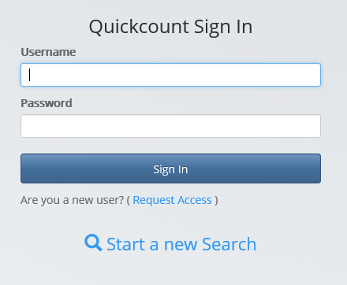
To get started, just click “Start a new Search”.

No login is needed to use this tool.

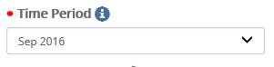

Now you can make your selections. Time Period and Primary Program are required.

Add more data to the results by also selecting a Comparison Program.

Filter the results, by selecting a Program Filter or a demographic filter from the Filter Menu.

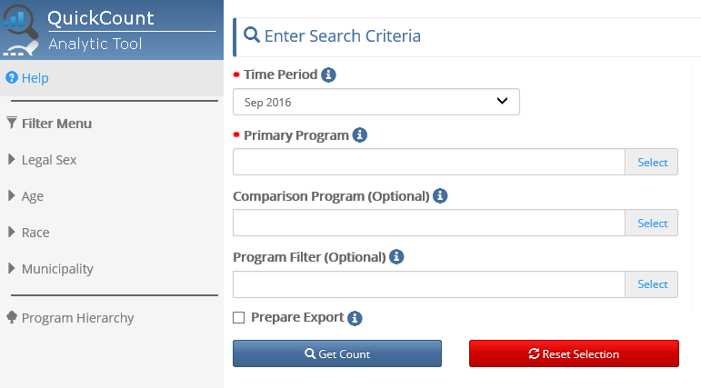

The Program Hierarchy is a list of all available data.
Clicking the for more details.

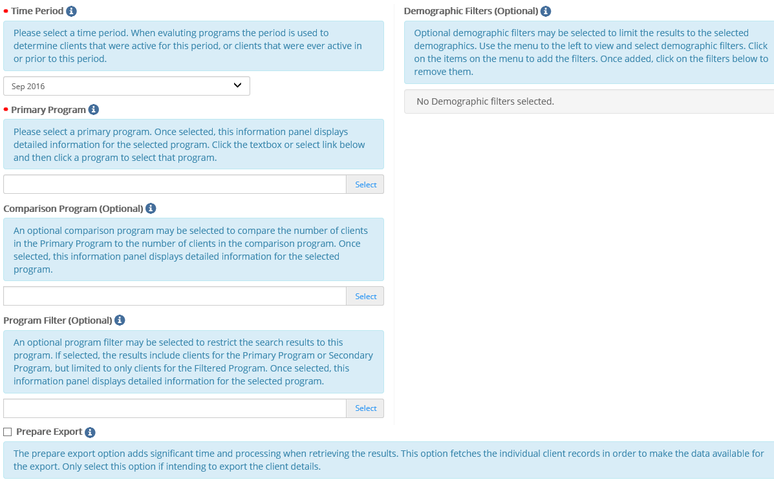

Let’s walk through some examples.

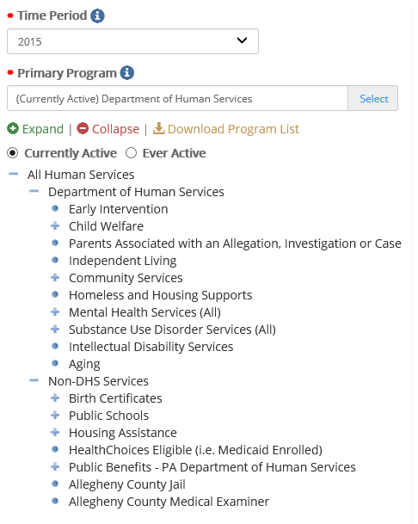
How many clients were active with DHS in 2015?

Click Time Period and choose 2015 from the list.

Click Primary Program, choose Currently Active, and select Department of Human Services.

Click Get Count

*Note: Currently Active refers to the time period chosen. So in this example, currently active = active in 2015.

Hints:
Currently Active and Ever Active seen at the top of the program list may be toggled simply by clicking the hollow dot to the left of the text.

The program tree may be expanded and collapsed wherever there is a + or – symbol. The dots represent the lowest level.
The QuickCount can be found at the bottom of the screen along with some additional information.

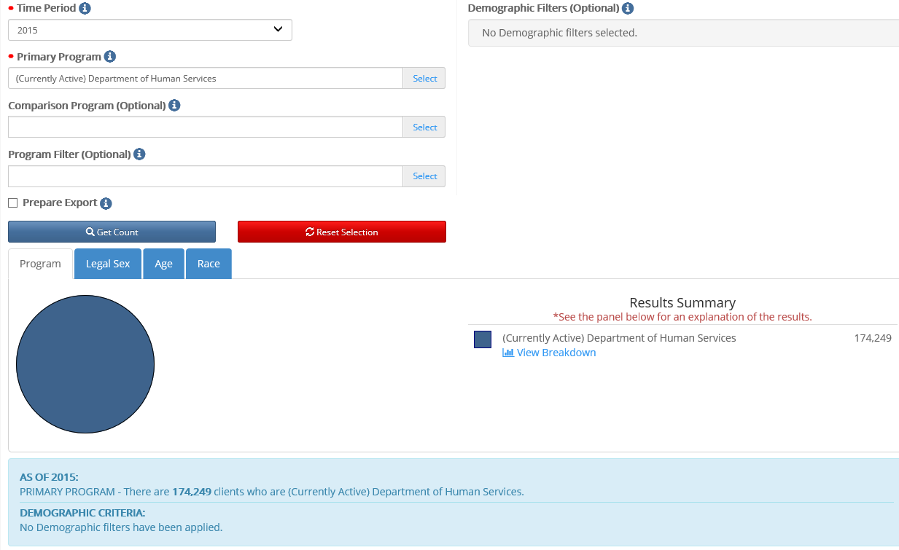

The narrative describes the selections and results. The tabs provide additional views of the data.
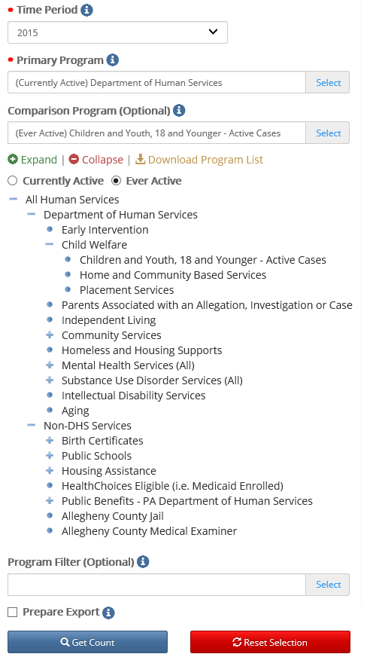
How many clients were active with DHS in 2015 and were ever part of an active case as children with Children and Youth Services?

Click Time Period and choose 2015 from the list.

Click Primary Program, choose Currently Active, and select Department of Human Services.

Click Comparison Program, choose Ever Active, and select Children and Youth, 18 or Younger – Active Cases.

Click Get Count

*Notes:
Currently Active refers to the time period chosen. So in this example, currently active = active in 2015.

Ever Active = Ever Active from the chosen date backwards in time. So in this example, ever active = active before and through 2015.

Data has been added to the result as can be seen in the Results Summary, but the original count is still available.
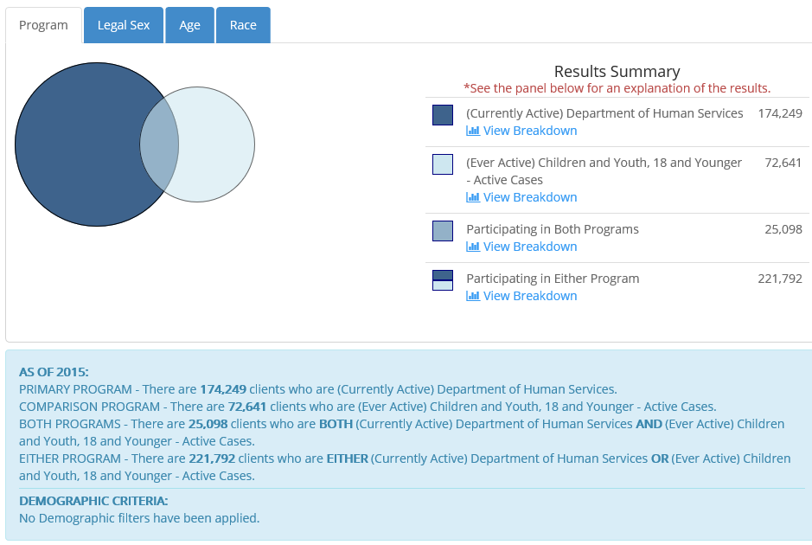
Clicking View Breakdown in the Results Summary will provide details on the Legal Sex, Age and Race tabs.
For example, to see breakdowns for clients in both programs, chose Participating in Both Programs from the Results Summary (results below).
To choose another breakdown, choose the Program tab and change the selection.

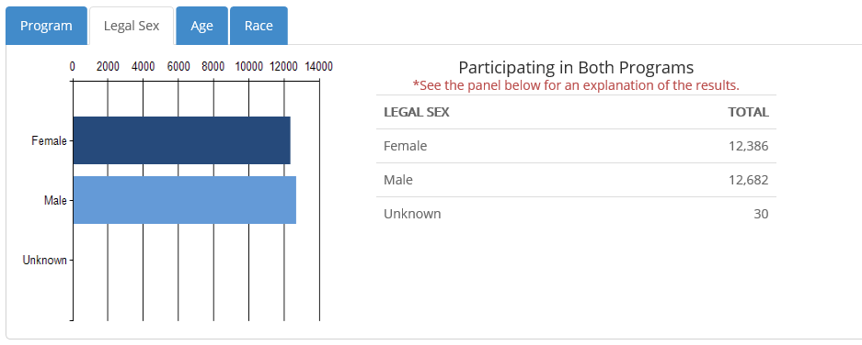
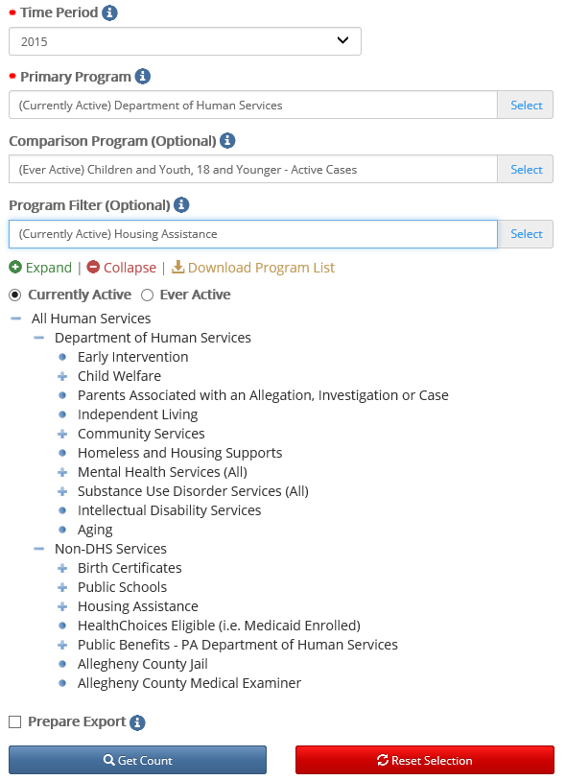
How many clients were active with DHS in 2015 and were ever part of an active case as children with Children and Youth Services and received non-DHS Housing Assistance?

Click Time Period and choose 2015 from the list.

Click Primary Program, choose Currently Active, and select Department of Human Services.

Click Comparison Program, choose Ever Active, and select Children and Youth, 18 or Younger – Active Cases.

Click Program Filter, choose Currently Active, and select Housing Assistance under non-DHS Services.

Click Get Count

*Notes:
Currently Active refers to the time period chosen. So in this example, currently active = active in 2015.

Ever Active = Ever Active from the chosen date backwards in time. So in this example, ever active = active before and through 2015.

Notice the results are now FILTERED to those clients matching the filter criteria. The narrative explains further.

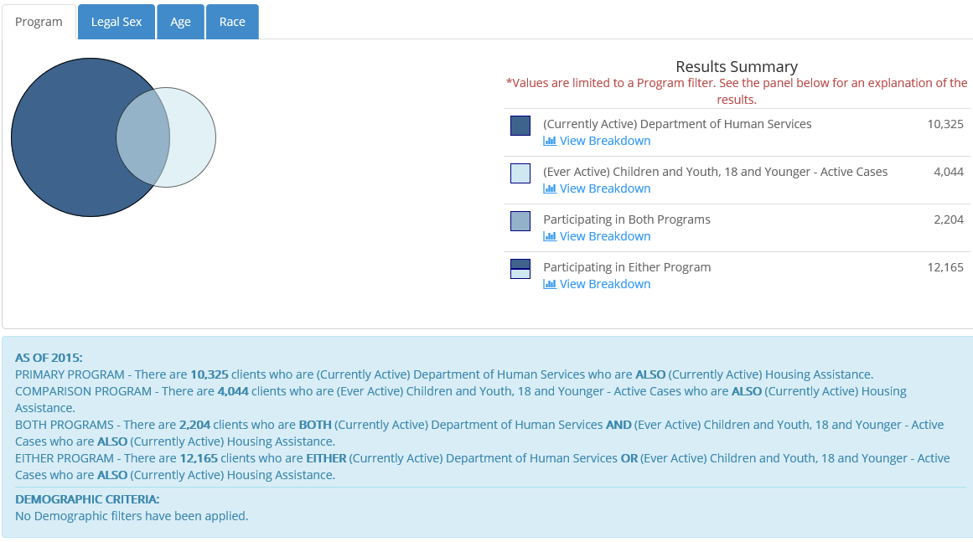

Clicking View Breakdown for Participating in Either Program provides Legal Sex, Age and Race graphs and counts.
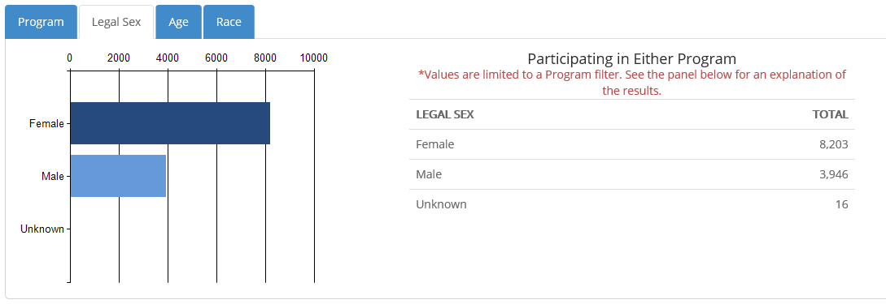
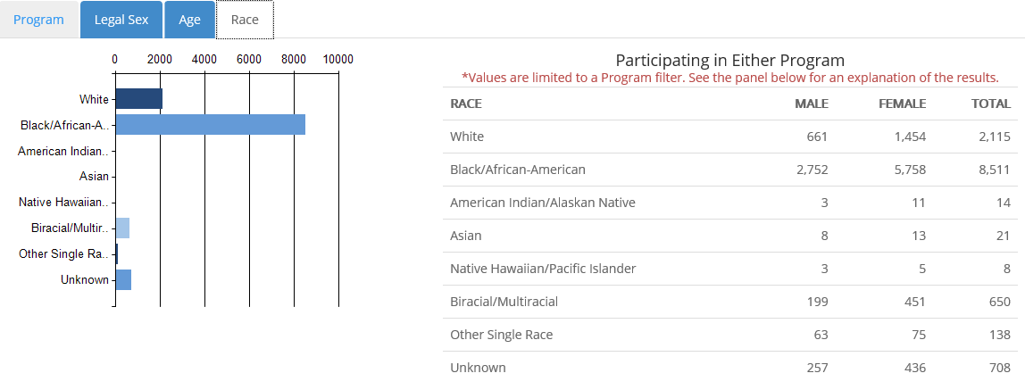
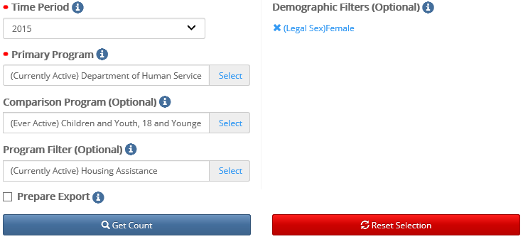
*Hint – selections can be seen in the demographic filter section.

*Notes: Currently Active refers to the time period chosen. So in this example, currently active = active in 2015.

Ever Active = Ever Active from the chosen date backwards in time. So in this example, ever active = active before and through 2015.

How many clients were active with DHS in 2015 and were ever part of an active case as children with Children and Youth Services and received non-DHS Housing Assistance and where female?

Click Time Period and choose 2015 from the list.

Click Primary Program, choose Currently Active, and select Department of Human Services.

Click Comparison Program, choose Ever Active, and select Children and Youth, 18 or Younger – Active Cases.

Click Program Filter, choose Currently Active, and select Housing Assistance under non-DHS Services.

Choose the Filter Menu: Legal Sex = Female

Click Get Count
Notice the results are now FILTERED to those clients matching the filter criteria. The narrative explains further.

